**Flight Testing Model Checklist**

This checklist is designed to aid students in setting up models for flight testing. Before the day of flight testing, all these elements need to be checked to help ensure a successful flight test campaign. A time should be arranged with the flight test pilot, ground crew and supervisor prior to testing to ensure the aircraft is set up correctly.

Conducting a successful flight-testing campaign is no easy feat but it is extremely rewarding to those who persevere.

Model Name: ………………………………………………………….....… Weight: ……………….

**Flight Testing Model Checklist**

**Safe Operation Procedures**

* An estimate of the approximate stall speed of the aircraft

**Build Quality**

* Model is strong enough to withstand
  + Aerodynamic forces at test airspeeds and angles of attack/sideslip
    - At a minimum, must be able to support weight of aircraft when held by wingtips
  + Vibrations from motor(s)
  + Maintain the required position of the battery/batteries and/or other dense/heavy equipment/payload
* Wires correctly insulated, including (but not limited to) around
  + Battery connectors
  + Solders onto PCBs such as Power Distribution Boards
  + Motor connectors and ESCs
* Model contains appropriately sized
  + Wiring and connectors for expected currents under load
  + Motor/ESC/Propeller matched for expected loads
* Wires (including signal wires) and electronics appropriately restrained within the model
  + Must be restrained for all attitudes (aircraft can be inverted without parts rattling around)
* Solder joints
  + Heat-shrunk
  + Strong (can be pulled on with reasonable force)
* Centre of gravity in the correct location
* Adequate cooling for equipment

**Propulsion System Set Up**

* Propellers
  + Balanced
  + Correctly tightened
  + Free from stress marks or damage
  + Rotate in the correct direction
* Electric:
  + ESC
    - Correctly calibrated ESC throttle range
  + Motor(s)
    - Fastened to the firewall(s) appropriately using Loctite
    - Runs freely and rotation is not impeded (no foreign material in bell, doesn’t rub against cowls)
    - Throttle direction and motor-cut set correctly on transmitter
  + Battery/Batteries
    - Mounted in suitable, secure location
    - Cabling and connectors in good condition
    - Suitably secured to the airframe
* IC (Internal Combustion)
  + Engine(s)
    - Fastened to the firewall appropriately using bolts and locknuts
    - Throttle servo securely attached in airframe with free movement of the throttle cable/linkage
    - Throttle set up correctly on transmitter
  + Fuel
    - Fuel tank suitably secured to the airframe
    - Fuel lines not inhibited in flight
    - Suitably set up to provide fuel in all aircraft orientation and attitudes
  + Safe and reliable way to start engine(s)

**Control Surface Set Up**

* General
  + Servo arm at 90 degrees at mid PWM (1500 )
  + Control surface mechanically aligned at trailing edge at mid PWM (as close as possible)
  + Servos sub-trimmed to align at the control surface and wing at the trailing edge
  + Control linkages ridged yet free to rotate and keepers/Loctite used
* Control Throws
  + Aileron : degrees, unless otherwise specified by user manual
  + Elevator : degrees, unless otherwise specified by user manual
  + Rudder : degrees, unless otherwise specified by user manual

**Flight Controller Set Up**

* Correct firmware loaded on flight controller
* System full set up and calibrated
  + Aircraft motion and HUD match
    - Magnetometer and Accelerometer calibrations
  + Transmitter control inputs calibrated
  + System responds correctly to input commands (i.e. rolls/pitches the correct direction)
  + System attempts to correct itself if perturbed (i.e. attempts to roll level if banked)
  + Flight data logging correctly set to acquire required data
* Can connect to the flight controller from the Ground Control Station
* System must be able to be armed and disarmed remotely
* Procedure to fall back to manual control set in case of flight controller failure

**Flight Test Planning**

* General
  + Specify the desired outcomes of the flight test campaign
  + Specify any additional hazards particular to the flight test campaign (e.g. experimental software)
  + Specify the location of the centre-of-gravity
  + Any additional details the flight test pilot needs to know
  + Prefetch (download) any maps required. Internet may not be available
* Flight Planning
  + A list of tests to conduct (in order)
    - Required details include test airspeed/s and operating altitude/s
    - If applicable, a set of alternate tests in case proposed tests don’t work
  + An estimate of the duration of the tests and flight time available per battery
  + Details on battery monitoring and “come home” criteria (e.g. min. allowable voltage)
  + Procedures for loss of GCS connection, radio control connection, or GPS signal
  + Any automatic flight plans should be simulated (if possible)
* On-Field Data Quality Checking and Verification
  + Where possible, scripts for checking acquired data should be pre-written and tested such that acquired data can be sanity-checked
    - Finding out the acquired data is corrupted once the day is complete is too late and the next opportunity to fly may be months away
* Field Equipment
  + A checklist of equipment required in the field including (but not limited to)
    - Computer and GCS
    - Pen and notebook for taking notes
    - Power / battery charging
    - Spares
    - Tools
    - Sunscreen, sunglasses, hats, (energy) snacks, and water

**Transmitter Set Up**

* General
  + The transmitter should be set up as shown below with all switches replicating the diagram as closely as possible. Always confirm the transmitter set up (including switch functions) with the pilot before flying
* Dual Rates / Expo
  + Dual Rates : 100 %, 80 % and 60 % for High, Mid and Low respectively
  + Expo : 20 % for all control surfaces for all rates

**Flight Modes**

RTL

FBWA

Manual

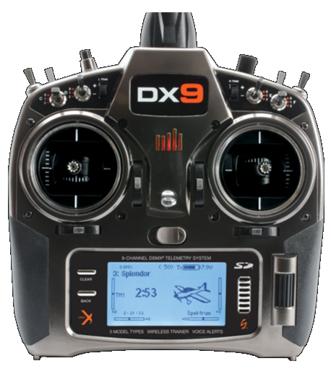

**Throttle Cut**

Throttle On

Throttle Cut

**Elevator D/R**

High: 100 %

Mid : 80 %

Low : 60 %

**Aileron D/R**

High: 100 %

Mid : 80 %

Low : 60 %

Pitch Forward

Pitch Backward

Yaw Right

Yaw Left

Throttle Up

Throttle Down

Roll Right

Roll Left

**Mode 1**

**A Good Ground Station (GCS) Operator**

The following is a list outlining how to be a good Ground Station Operator. As the pilot is responsible for flying the aircraft, a GCS Operator is responsible for ensuring data is obtained in an efficient and effect manner. The GCS Operator must also manage the health of the aircraft, act as a spotter, and in general support the pilot in keeping the aircraft, operational crew and public safe.

* Be clear, be concise.
* Communicate problems before they become a serious issue. Don’t let them just fix themselves
  + Manage the health of the aircraft from the GCS
  + Don’t doze off or spend time just sitting and watching, inattentiveness attracts accidents
* Confirm commands by repeating them back to the pilot. “Yes” is not an acceptable reply
  + For example
    - Pilot: Set mode to “auto”
    - GCS Operator: Setting mode to “auto”
* Numbers should be said as individual digits
  + For example
    - GCS Operator: Climb to two-zero metres
    - Pilot: Climbing to two-zero metres